3rd Grade Classroom Newsletter
MATH
Numeration- representing numbers, understanding and counting the number line, finding the halfway number, and rounding
READING
Vocabulary: bat, battery, blew, fuel, plug, term, vision
-Literary Elements and Background Knowledge
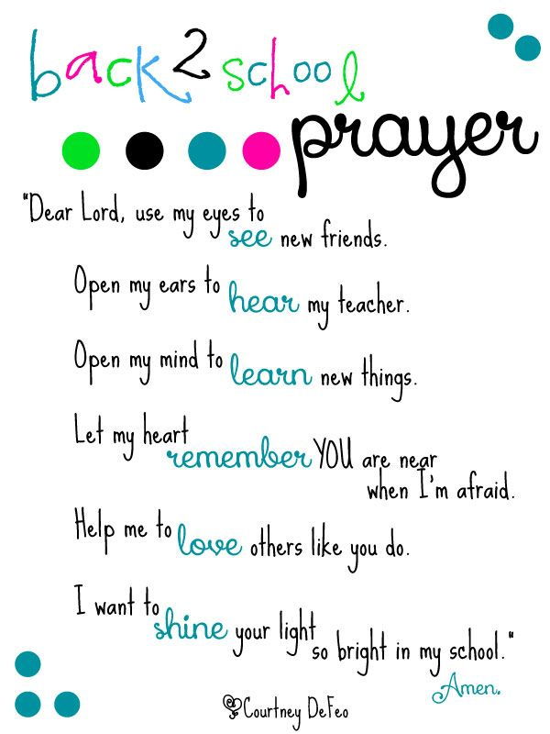
1. happen 9. lesson
2. lettuce 10. spelling
3. basket 11. napkin
4. winter 12. collar
5. sister 13. traffic
6. problem 14. suggest
7. supper 15. puppet
8. subject

Challenge words:
- skillet
- picnic
- planet
- system
- pumpkin

Spelling Words
Week of August 20th-24th
KEY EVENTS/ INFORMATION
Specials:
Monday: Library
Tuesday: P.E. and Music
Wednesday: Technology and P.E.
Thursday: Music and Technology
Friday: Art
Students need athletic shoes for the days when they are going to P.E.
RELIGION
Virtue of the Month: Peace
The Catholic Diocese of Wichita

SCIENCE/ SOCIAL STUDIES
- Exploring Our Solar System
- Democracy Studies Weekly

