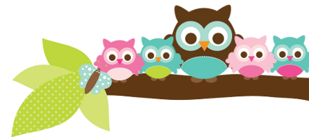
Mrs. Rose, Grade 5 & 6 January 25, 2024
Here’s what we’ll be learning the next 2 weeks:

5th ELA- We will continue to work out of our handwriting books. Next week will be E16 spelling words. The following week will be E17. We are still studying informational texts. In English we are working on adjectives.

5th Religion- We will be learning more about the Church and God’s mercy. We will be taking a religion test almost every Friday. Your child has a study guide each week.

5th Social Studies- We are still learning about the early colonies, particularly slavery and relationships with Native American tribes.

6th English- We have covered helping and linking verbs. Next we will start working on verb tenses.

6th Social Studies- We are learning about the Maya, Inca, and Aztec civilizations. We should finish our first textbook in the next 2 weeks.
A Note From Mrs. Rose – If your student is coming home without homework please have them do 20-30 minutes of iReady or MobyMax. We are trying so hard to have our scores go up. That would have the students more prepared for the next school year which would be wonderful!

Things to Know
If you are starting to purchase Valentines, please read this. Please only put your child’s name on the Valentines. I have the kids go up and down the rows and just drop the Valentines into bags. There are 21 kids in 5th grade. If students are trying to give specific Valentines to specific kids it can take 45 minutes to pass them out. We just don’t have that kind of time.

Important Dates
- Jan 25- 5th to the symphony
- Jan 28-Feb 2- Catholic Schools Week
- Feb 9- 5th to convent

Test Dates
- Jan 25- 5th vocab test
- Jan 26- 5th spelling & religion tests
- Jan 30- 6th linking verbs quiz
- Feb 1- 5th vocab test
- Feb 2- 5th religion & spelling test

Things Coming Up We still have quizzes and tests during Catholic Schools Week. I know that Catholic Schools Week gets the kids excited. Please make sure that they are still doing their homework and studying for tests.

Owl Aboard!

