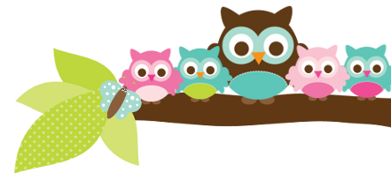
Mrs. Rose, Grade 5 & 6 October 13, 2023
Important Dates
- Oct 20- 1st quarter ends
- Oct 30-31 no school parent teacher conferences
Test Dates
- Oct 12- 5th vocabulary test
- Oct 13- 5th spelling & religion test
- Oct 17- 6th card #1-2 quiz
- Oct 19- 5th vocab test
- Oct 19- 5th spelling & religion test
- Oct 24- 6th cards #1-3 quiz

Things to Know
For the past 4 years my class has been visiting the convent multiple times a year. Last month the class got to see a magic show with the residents. Typically, during that visit we do some kind of craft with the residents. Most of the residents that we visit have some type of health restriction, so I will ask the students to wear a mask if they are sick. I will talk to them about how we can be respectful to people who are in wheelchairs so that everyone can have fun. We are so blessed to be able to practice this corporal work of mercy at the convent. Watching your children be the face of Christ to the residents is a special experience.

A Note From Mrs. Rose
Students need to be reading at least 20 minutes a night for their reading grade and to meet their AR goals. The end of the first quarter is next Friday. As of today less than half the students have met their AR goal. If the students are reading 20 minutes a night, they should easily meet their goals. Don’t forget, AR is also part of their reading grade.

Here’s what we’ll be learning the next 2 weeks:

5th ELA- We will continue to work out of our handwriting books. In spelling, I am sending out the list the Friday before. Next week is the E9 list, then the E10 list the following week. In English we are finishing nouns. Next will be verbs.

5th Religion -We will be learning more about professing our faith and God’s Word. We will be taking a religion test almost every Friday. Your child has a study guide each week.

5th Social Studies – We are finishing Native Americans. We are learning about the consequences of early explorers next.

6th English- We just started prepositions. Now that we have that started, they will have a quiz every Tuesday over prepositions or something else we have covered. I will tell them a week in advance what the quiz will cover.

6th Social Studies- We will be covering Egypt and the pyramids for the next 2-3 weeks.
Things Coming Up Conferences are coming up. Please keep an eye out for the sign up email from the school office. I do prefer to have the students come to their conferences. It is, after all, their education and responsibility. However, I understand if you are coming from work that you would not have time to bring them with you.

Owl Aboard!

