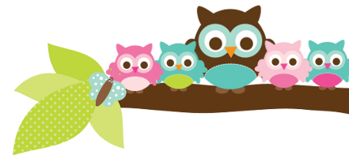
Mrs. Rose, Grade 5 & 6 October 27, 2023
Important Dates
- Nov 1- no school
- Nov 9- picture retakes
Test Dates
- Nov 2- 6th cards 1-4 quiz
- Nov 7- 6th cards 1-5 quiz
- Nov 9- 5th vocab test
- Nov 10- 5th religion and spelling tests

Things to Know

Don’t forget that all notes are also posted on my All Saints web page at
http://www.allsaintswichita.com/fifth-grade.html

The students all have passwords in the front cover of their agenda. These passwords are for their email, clever, and AR. If your student has no homework other than reading, MobyMax, or iReady would all be a good use of their time. All of our students’ educations have been affected by Covid. Time they spend on these programs is invaluable. They all have learning gaps that these programs can fill.

Make sure you are checking behavior cards every week.
Here’s what we’ll be learning the next 2 weeks:

5th ELA- We will continue to work out of our handwriting books. In English we have started our verbs unit. The spelling words can be found on Spelling City. Next week is list E-10.

5th Religion We will be learning more about the Communion of Saints. We will be taking a religion test almost every Friday. Your child has a study guide each week.

5th Social Studies We are studying the early explorers and how they changed the tribes of the Americas.

6th ELA- We have been learning about prepositions and prepositional phrases for the last 2 weeks. We will work on this through November. I plan to give a semester final over nouns, adjectives, and prepositions. They need to study their notes and notecards on a regular basis.

6th Social Studies- We are learning about early Israel, their culture, and the time of Jesus.
A Note From Mrs. Rose Please continue to make sure your student is doing their homework and studying. Also, they need to be reading at least 20 minutes a night for Reading class and to meet their AR goals. Many students did not meet their first quarter AR goal. The students need to do a better job since it is reading grade every quarter in both grades.

Things Coming Up Please make sure as the weather gets colder that your child brings a jacket for recess. If it is cold outside and they do not have a jacket or coat they will still have to go outside. If you are unable to provide a jacket for your child at this time, please contact me by email or phone call.
Owl Aboard!

