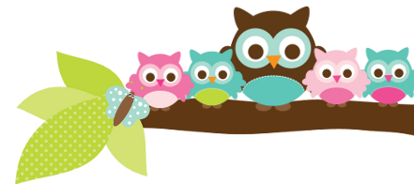
Mrs. Rose, Grade 5 & 6 December 3, 2022
Here’s what we’ll be learning the next 2 weeks:

5th ELA- We will continue to work out of our handwriting books. This week we are doing the E-12 spelling list. Next week will be E-13. E-14 will be our last list before the break. In English we are halfway through our verb unit.

5th Religion We will be learning more about The Lord’s Prayer, Advent, and Christmas. We will be taking a religion test almost every Friday. Your child has a study guide each week.

5th Social Studies - We are wrapping up our unit on Plymouth and will move into a unit on life in the early colonies.

6th English- We are still working on prepositions and that will continue until Christmas break. There will be 3 more quizzes, 1 test, and 1 final before the break.

6th Social Studies- We just started ancient China this week.
Important Dates
- Dec 2- spirit day
- Dec 8 – we DO have school
- Dec 12- no school
- Dec 16- Christmas concert
- Dec 19- convent field trip
- Dec 21- dismiss at 11:30, end of 2nd quarter

Test Dates
- Dec 6- 6th cards #3-4 quiz
- Dec 8- 6th prepositions test
- Dec 8- 5th vocab test
- Dec 9- 5th religion & spelling tests
- Dec 13- 6th cards #4-6 quiz
- Dec 15- 6th 1st semester English final
- Dec 15- 5th vocab test
- Dec 16- 5th religion & spelling test

A Note From Mrs. Rose – I can see that not all my students are studying enough for religion tests. If I have marked their test “study” or “study every night”, they really need to be studying. If they do not study, I am concerned that they won’t pass their Religion assessment in May.

Things to Know
I am asking that you sign your student’s tests and behavior reports. In the past I have had issues with low test grades and some of the students not studying. This procedure is to keep you aware of how your child is doing.

Make sure the kids are dressed warmly for morning recess especially.

Things Coming Up The second quarter will end soon. Not a single one of the 5th grade students have met their AR goal. Please make sure that your student is reading. If they do not get reach their goal it will affect their reading grade.
Owl Aboard!

