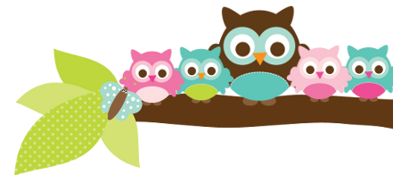
Mrs. Rose, Grade 5 & 6 February 8, 2024
Here’s what we’ll be learning the next 2 weeks:

5th ELA- We will continue to work out of our handwriting books. In English we are moving into grammar and punctuation. Next week is the E-18 spelling list, then the E-19 list.

5th Religion We will be learning more about Holy Orders, Matrimony, and living as Christians. We will be taking a religion test almost every Friday. Your child has a study guide each week.

5th Social Studies We are beginning to discuss the things in our history that led to the American Revolutionary War.

6th English We are finishing verbs and will take the test next week. They are getting better at taking sentences apart and being able to identify how each word is used in that sentence.

6th Social Studies We started a new book last week! We are finished reviewing a few skills and moving into learning about ancient Greece.
Things to Know
These kids are working hard! My biggest concerns are still reading comprehension and math skills. Make sure they are reading at night and if possible, ask them questions about what they are reading. Have them tell you a few things about the book they are reading. You could also have them read you a few paragraphs. They can get on iReady Math or Moby Max Math as well.

Important Dates
- Feb 13- 2:30 parties
- Feb 16 & 19- no school
Test Dates
- Feb 8- 5th vocab test
- Feb 9- 5th religion & spelling test
- Feb 13- 6th helping verbs quiz
- Feb 15- 6th verbs test
- Feb 15- 5th vocab test
- Feb 15- 5th religion & spelling test

A Note From Mrs. Rose – Be sure to ask your student about their Star Card in my room. Your child will be making progress on this through the entire semester as they work or behavior and improving their grades. They are trying to get on my “wall of fame.”

Things Coming Up AR goals have to be met by March 1. I have students who are not taking tests. Only a few students have met their goal for the quarter. Don’t forget, AR is a grade for them in Reading. If they are reading 20 minutes every night, they should have no problem meeting their goal.
Owl Aboard!

