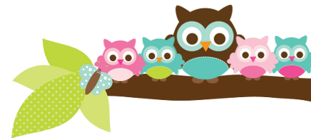
Mrs. Rose, Grade 5 & 6 April 20, 2023
A Note From Mrs. Rose
As it gets warmer outside, please make sure that your children are using good hygiene. If they need deodorant, make sure they wear it daily, and shower regularly.

The students should be logging in to iReady or Moby Max on nights that they do not bring work home.

We should be taking our Diocesan Religion Assessment the first weeks of May.

Important Dates
- April 20- bowling alley
- April 25- 5th to the convent
- May 5- May Crowning rosary, spirit day
Test Dates
- April 20- 5th vocab test
- April 20-6th pronouns test
- April 21- 5th religion & spelling tests
- April 24- 5th & 6th Math State Assessment
- April 25- 5th & 6th Math State Assessment
- April 27- 5th vocab test
- April 28- 5th spelling & religion tests

Things to Know Please make sure your child has eaten breakfast and is here on time for state assessment days. From experience at home I know getting the kids to school can be stressful. On those days if they are happy when they get here they have a better chance of performing well. Try to keep those mornings as positive as possible. Good luck!

Here’s what we’ll be learning the next 2 weeks:

5th ELA- We continue to work out of our handwriting books. The next spelling list is E-23. The first week of May will be list E-24. The class is working on their 2-page writing assignment. It is due on May 3rd. In English we are beginning pronouns.

5th Religion We are preparing for the Diocesan Religion Assessment. Your child should have a study guide.

5th Social Studies We are studying the Bill of Rights and the new government after the Constitution.

6th English- We are finishing our pronoun unit. Next we do conjunctions and confusing words.

6th Social Studies- We are entering the Middle Ages and will likely not finish them before the end of the school year.
Things Coming Up Please make sure your child is reading every night and ask them about AR tests on the books they read. I would love to have all my students reach their AR goal this quarter.
Owl Aboard!

