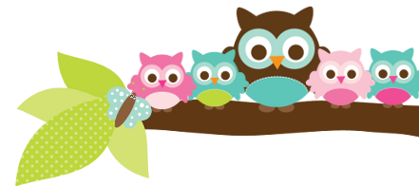
Mrs. Rose, Grade 5 & 6 September 1, 2023
Here’s what we’ll be learning the next 2 weeks:

5th ELA- We will do 2 pages of handwriting every week. We are doing spelling words from E-2 this week and E-3 next week. We have a spelling and vocab test every week. In English we are finishing a unit on subjects and predicates, then we will start nouns.

5th Religion- We are studying the sacraments and the Beatitudes. We will have a religion test almost every Friday all year, and have already started studying for the DRA in May.

5th Social Studies- We are learning about the steps of the inquiry process.

6th Social Studies- We are studying early man right now.

6th English - We finish our noun unit this week. The test is Thursday. The test will be hard. The students are expected to have 17 rules for nouns memorized. Next we start adjectives.

Things to Know
I am asking that you sign your student’s tests and behavior reports. In the past I have had issues with low test grades and students not studying. This procedure is to keep you aware of how your child is doing.
Don’t forget we have Homework Club after school for late work on Tues-Fri only. It ends at 4:00. The students will dismiss out the main door.
If you have any questions, please email me. I try to answer quickly.

Important Dates
- Sept 4- no school
Test Dates
- Aug 31- 5th vocab test
- Sept 1- 5th religion & spelling test
- Sept 7- 6th nouns test
- Sept 7- 5th vocab test
- Sept 8- 5th religion & spelling test
- Sept 14- 5th vocab test
- Sept 15- 5th religion & spelling test

A Note From Mrs. Rose This school year has started well. I’m excited about how things are going with both 5th and 6th grade. I am very optimistic that we will have great year.
I will be posting newsletters on my website 2 times a month. www.allsaintswichita.com/fifth-grade.html

Things Coming Up The end of the first quarter will be here before we know it. Make sure your child is reading at home so they can meet their AR goal. Also, please check your student’s grades often on PowerSchool. If you need any help with PowerSchool please let me know. I would be happy to help.
Owl Aboard!

