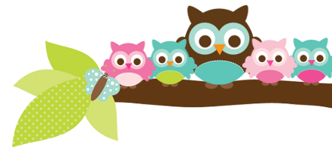
Mrs. Rose, Grade 5 & 6 September 15, 2023
Important Dates
- September 21- picture day
- September 22- no school
- September 29- last day to wear shorts
Test Dates
- Sept 21- 5th vocab test
- Sept 21- 5th spelling & religion test
- Sept 28- 5th vocab test
- Sept 29- 5th spelling & religion test

Things to Know
5th grade- Starting next week if a student scores below a 75% on their weekly test they will have to stay after and study religion one day with me. I send home a note home several days before the study date. I do this to keep students from falling behind and I do have students who are failing the tests. There are well over 100 things they need to know for their DRA in May.

6th grade- Several students have very low grades in English. I am asking them to slow down and look at each word in the sentences. Please talk to them at home about taking their time.

Here’s what we’ll be learning the next 2 weeks:

ELA- We will continue using our handwriting books. There will be a vocab and spelling test every week. We will start a new list each week. Next week is E5, the following week is E6. I try to send it home every Friday. In English we will be studying more about nouns.

Religion- We will be learning more about the Baptism and Confirmation. Your child has a study guide each week for the test.

Social Studies - We are still working on our inquiry unit.

6th English- We are working hard on adjectives. We should have a test in the next two weeks. Then we will begin prepositions.

6th Social Studies- We are working on a unit on the early civilization of Mesopotamia.
Things Coming Up Picture day is coming up next week. Check the handbook if you are not sure what your student should wear.
A Note From Mrs. Rose Please continue to make sure your student is doing their homework and studying. Also, they need to be reading at least 20 minutes a night for Reading class and to meet their AR goals.
The end of the first quarter will be here soon. Don’t forget, AR is part of their reading grade and I only have 1 student who is finished.

Owl Aboard!

